**Day 4 Lab Assignments**

**Please do these assignments:**

1. Make a registration form (you can re-use the registration form you did before) as the following (Use HTML 5 new input types and validation attributes):
   1. Form fields:
      * Full Name (Required)
      * Email (Required, input type: email)
      * City (Drop-down list filled with some cities)
      * Password
      * Repeat password.
      * “I accept the terms and conditions” checkbox.
      * Register button, which redirects to another page saying: “Thank you, *Full Name* for registering in our website”.
   2. Make full name text has default text “Enter your Name:” [use placeholder attribute].
   3. When the user focus in full name text, show blue border for the input (use element.style.border=”solid 1px blue”), and remove the border when the input loses the focus.
   4. After user finish writing his full name and leaves the text box (lost focus), if full name wasn't in correct format (not empty string and more than 3 letters), show text next to textbox saying “invalid name”, and focus the full name textbox, and select all text on it, else if full name was in correct format hide the text next to textbox.
   5. **For Password and repeat password fields, when the user leaves the repeat password field, we need to validate that they’re required, and they’re identical (The same), and if they’re not the same show text besides it saying “password and repeat password should be the same”; remove the validation message when the user enters it correctly [Bonus].**
   6. Change the background color of the text input when it’s not valid to: gray, and to white when it’s valid.
   7. **For the Email, use HTML5 “Required” attribute, and input type email.**
      * **You’ll remark that HTML5 validation will prevent you from submitting the form unless it’s valid, right?**
      * **But for the other custom validation of the name and password & repeat password, will not prevent the form for submitting and you can submit the form even if they’re not valid, why? [Bonus]**
2. Make a photo gallery with buttons: play (start changing image every 0.5 sec), stop, next, previous, and also make it start automatically when mouse is over it.
3. Create a simple photo gallery like the following, and use opacity property to make each image fades out gradually (its opacity decreases to 0.3 gradually) when mouse is over it, and fades in gradually (its opacity increases to 1 gradually) when mouse is a way.



1. Use HTML Dom, to do the following:
   1. Create image node (using document.createElement()).
   2. Set it source image (using setAttribute()).
   3. Append it to a div on the page (Try appendChild() and insertBefore(), what’s the difference)?

**Bonus assignments:**

1. Check and try demos in this link for more about form validation: <https://css-tricks.com/form-validation-ux-html-css>
2. Make a page that contains an empty star image (provided in the lab files), and changes as following (like star rating control):
   1. When mouse over it, it converts to filled star (like rating stars control, but you can try it on one star only in the beginning, then change it to 5 stars).
   2. When mouse move away from it, it changes back to empty star.
   3. When mouse over it, and it clicked, make it fixed on the filled star (don’t changes again when mouse move away from it).
   4. When re-clicked again (after it was fixed from first click), it backs to empty star when mouse is out.

stars

1. Make a search textbox, that when mouse is on it (on focus), it’s width increases gradually, and when mouse is out (on blur), it backs gradually to its original width (like this one here: <https://www.w3schools.com/howto/tryit.asp?filename=tryhow_css_anim_search> , and note that the given demo is done using CSS3 transition, but you need to make it **using JavaScript only without using CSS 3 transition or animation**).
2. Create an image like the following one, which has an image, image description text under the text and prev. and next buttons.  
    (Use array to store images name, and another to store images description) [You may use one associative array, instead of 2 arrays].
   1. Make the slide show start automatically when page loads.
   2. When the mouse is over an image show this image description below it and pause the slide show.
   3. When the mouse moves away from the image hide the description and resume the slide show.
   4. When the mouse is over next or Prev. buttons stop the slide show, and when the mouse moves away from them, resume the slide show.
   5. Make next button display the next image, and prev. button display the prev. image.

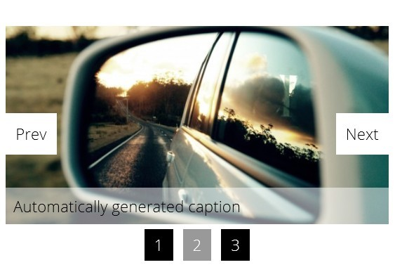

1. Make a div with width and height: 100px, and make a border and background color for it, and make an image that can be dragged and dropped on the div.
   1. Make the image back to its original position if dragged to any place rather than the div.
   2. Change the div background when the image is dropped over the div.
2. Complete stars assignment be complete 5 star rating control, that user can select rating from 1 to 5 stars (For example: if the user clicked on the the 3rd star all 3 stars should be filled and fixed, and when click on the 1st star one star only should be filled and fixed, and so on).
3. In the login form assignment (Assignment No.2), add “Show password” button besides the password input that changes the input type to “text” when checked, and changes it to “password” when unchecked. [use:document.getElementById("myInput").type].

[Make the final design of the textbox like the following image].

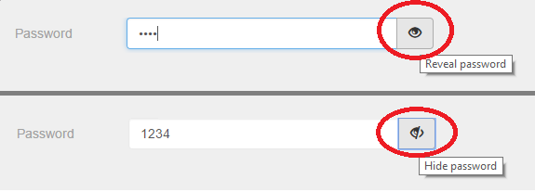

1. What’s Captcha validation, search for it and try to implement it using JavaScript?
2. Make a toggle like button like the following: <https://www.w3schools.com/howto/howto_js_toggle_like.asp>
3. Make password validation like the following:

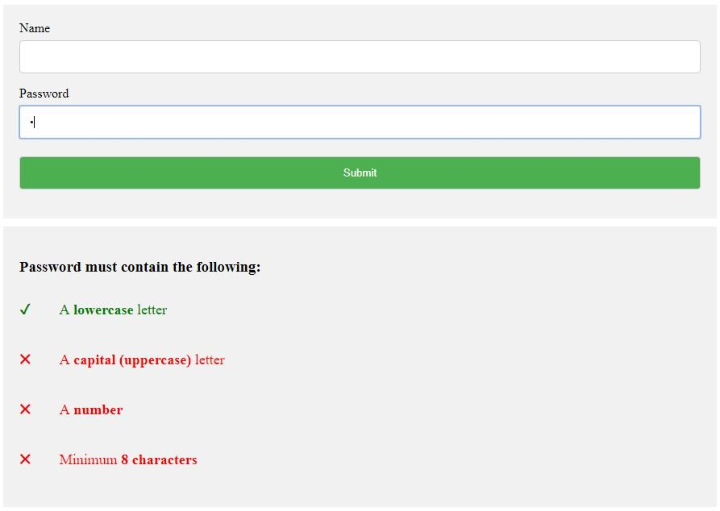

1. Make the label next to “I accept the terms and conditions” checkbox, as a link that opens new window contains terms and conditions.
2. Style the registration form like the following style:

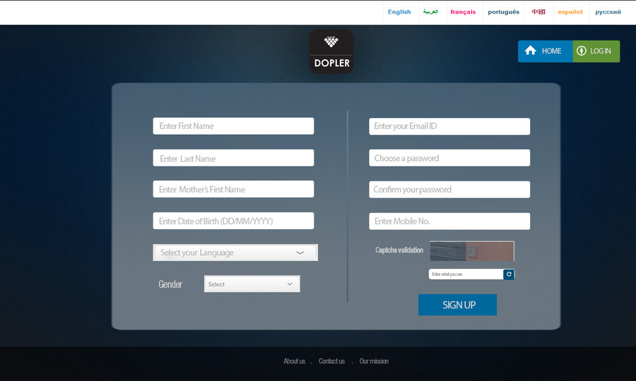

1. In the form assignment, add a dropdownlist to select gender (Male, female), and after select from it, write a text below it “Your Name: Mr. OR Ms.+ his entered name” based on his selected gender.
2. Make full page background image with parallax scrolling effect (Scrolling background image) in a page, like the following website: <https://www.soundsnap.com> (Make a home page like this website with all CSS effects on it)  
   (You can follow the following demo to know about the parallax scrolling effect: <https://www.w3schools.com/howto/tryit.asp?filename=tryhow_css_parallax>).
   1. Change the background image to background video. You can follow the following tutorials:

<https://www.w3schools.com/howto/howto_css_fullscreen_video.asp>

<https://medium.com/@aswin_s/fullscreen-video-backgrounds-e8376ef93c72>

1. Design a list of skills like the following, any item when mouse over it, its background color should change to blue, and when click (X) of each one it should closed.
   1. Handle that when write text and press enter it converted to clickable label like the below.

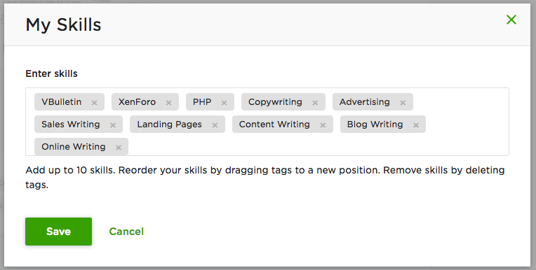

1. Use CSS & DHTML to create HTML page that has dropdown menu like (or any menu style you like):

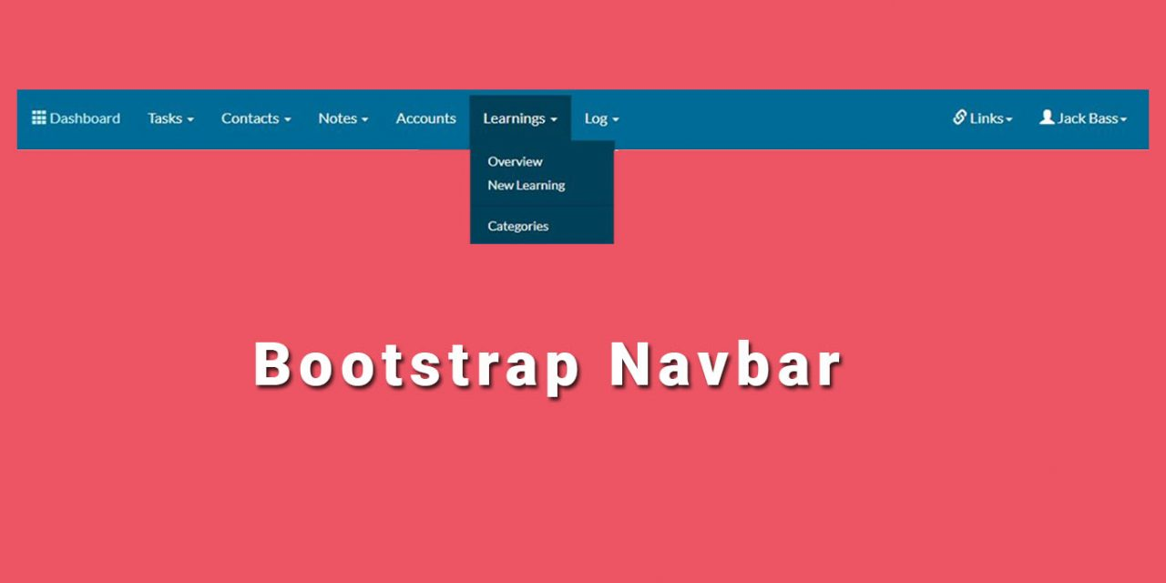

* 1. Try position: fixed, and position:sticky for the navbar.
  2. Make the navbar items as list (ul), and inside each list item (li), add a link for each menu item.
  3. Use list style type: none for the list items.
  4. Use display: inline-block for the list items. (Why?).

1. Make a fixed nav-bar like this one in souq.com, or linked-in: <https://egypt.souq.com>, <https://www.linkedin.com/feed/>
   1. Handle the left menu icon that opens side menu (in souq.com)
   2. Handle the drop-down menu in the nav-bar (In linkedin.com)
2. Follow the following demos to see how to center elements horizontally and vertically:  
   <https://www.w3schools.com/css/css_align.asp>   
   <https://css-tricks.com/centering-css-complete-guide>
3. Make a span that contains text "Welcome to our website" with small red color font, and make it follows the mouse pointer position (moves to the mouse cursor position when mouse move on the document) [You need to handle mousemove event on the document, and set a width and height to body or add long content to it, and you should set the position property of the span, what value for the position property you should use?].
   1. Make the span disappears when mouse is down, and appears again when mouse is up.
4. Make the tiger in the demos, flips to right and walks to the right until it reaches the end of the page, and when it's at the end of the page, and clicked it flips to left and walks to left until it reaches the start of the page.
5. For the given html page that contains a car image:
   1. Make the car when clicked, moves to right gradually until it reaches the end of the page and stops.
   2. When it's moving write its current left below it.
6. In car assignment, make it when clicked again, it back to its old place (returns back gradually).
7. Make a simulation for bowling game (some vertical images and you have another image that can move it vertically using keyboard arrows, and when click it, moves and hit the images in front of it).
8. Do the optional bonus assignments provided in the lab folder.
9. Complete Day3 Bonus Assignments.

**<Script>document.write(“Thank YOU”) </Script>**